

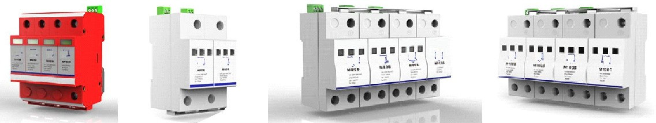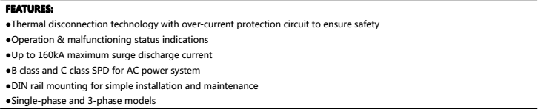

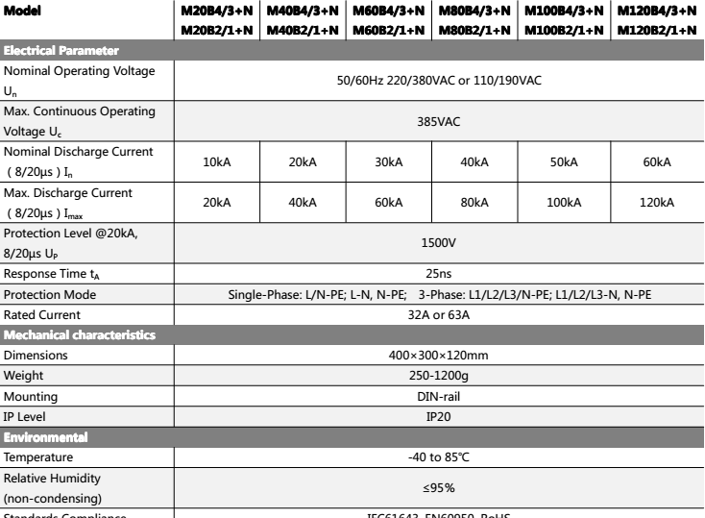

**Welltech Enterprises**

415 Ground Floor, PRAKASH MOHALLA, GARHI , EAST OF KAILASH

NEW DELHI 110065

Phone +91 9871650366 Email : sales@welltechenterprises.in